VB NET PROGRAMLAMA DİLİ ÖRNEKLERİ

Metin kutuları kullanan program
Dim A, B, C, DELTA, X1, X2 As Single
A = TextBox1.Text
B = TextBox2.Text
C = TextBox3.Text
DELTA = B ^ 2 - 4 * A * C
TextBox4.Text = DELTA

TextBox5.Text = ""
TextBox6.Text = ""

If DELTA < 0 Then
Label7.Text = "KÖK YOKTUR!"
End If

If DELTA = 0 Then
Label7.Text = "TEK KÖK VARDIR"
X1 = -B / 2 / A
TextBox5.Text = X1
TextBox6.Text = ""
End If

If DELTA > 0 Then
Label7.Text = "ÇİFT KÖK VARDIR"
X1 = (-B + DELTA) / 2 / A
X2 = (-B - DELTA) / 2 / A
TextBox5.Text = X1
TextBox6.Text = X2
End If

INPUTBOX KULLANIMI
Dim A, B, C, DELTA, X1, X2 As Single
A = CSng(InputBox("A DEĞERİNİ GİRİNİZ", "UYARI", 3))
B = CSng(InputBox("B DEĞERİNİ GİRİNİZ", "UYARI", 6))
C = CSng(InputBox("C DEĞERİNİ GİRİNİZ", "UYARI", 2))

DELTA = B ^ 2 - 4 * A * C

If DELTA < 0 Then MsgBox("HİÇ KÖK YOKTUR") : Exit Sub

If DELTA = 0 Then
MsgBox("TEK KÖK VARDIR")
X1 = -B / (2 * A)
MsgBox("X1=" & Math.Round(X1, 4))
Exit Sub
End If

If DELTA > 0 Then
MsgBox("İKİ KÖK VARDIR")
X1 = (-B - Math.Sqrt(DELTA)) / (2 * A)
X2 = (-B + Math.Sqrt(DELTA)) / (2 * A)
MsgBox("X1=" & Math.Round(X1, 4))
MsgBox("X2=" & Math.Round(X2, 4))
End If

PROGRAM ALGORİTMASI
1 | Başla
2 | Denklemin katsaylarnı oku a,b,c
3 | Diskriminant = b x b 4 x a x c
4 | Eğer Diskriminant < 0 ise Yaz "kökler sanal" Git 9
5 | K = Karekök(Diskriminant)
6 | X1 = (-b + K) /(2 x a)
7 | X2 = (-b - K) / (2 x a)
8 | Yaz X1, X2
9 | Dur

PROGRAM AKIŞ ŞEMASI
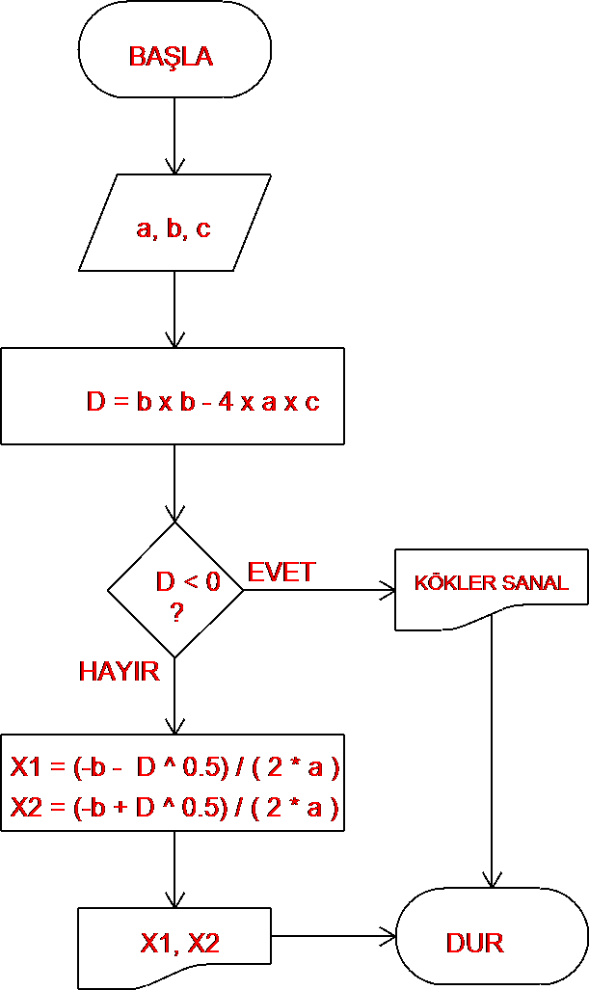

DEĞİŞKEN TÜRLERİ
VERİ TÜRÜ | AÇIKLAMA | KAPLADIĞI  ALAN | TANIM
Bayt | TAMSAYI | 1 | Dim HARF As Byte
Boolean | TAMSAYI | 2 | Dim CEVAP As Boolean
Integer | TAMSAYI | 4 | Dim YAS As Integer
Short | TAMSAYI | 2 | Dim CAP As Short
Long | TAMSAYI | 4 | Dim ALAN As Long
Single | ONDALIKLI SAYI | 4 | Dim ALIS_FIATI As Single
Double | ONDALIKLI SAYI | 8 | Dim TOPLAM_MALIYET As Double
Date | TARİH | 8 | Dim DOGUM_TARIHI As Date
Char | KARAKTER | 1 | Dim HARF As Char
String | METİN |  | Dim AD_SOYAD As String

ÇİZİM YAPAN PROGRAM
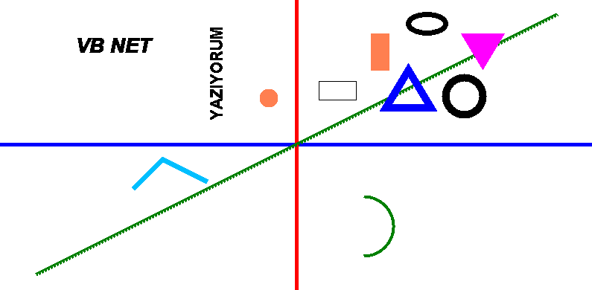

Dim RESIM As New Bitmap(800, 400)  Dim ÇİZ As Graphics = Graphics.FromImage(RESIM)  REM MERKEZ NOKTA 400 SAĞA 200 AŞAĞI KAYDIRILIR  ÇİZ.TranslateTransform(400, 200)  ÇİZ.DrawLine(New Pen(Brushes.Blue, 5), -400, 0, 400, 0)  ÇİZ.DrawLine(New Pen(Brushes.Red, 5), 0, 200, 0, -400)  REM ***X,Y GRAFİĞİ ÇİZDİRME***  Dim NOKTALAR As New Collection  For X = -350 To 350  NOKTALAR.Add(New Point(X, X / 2))  Next  For C = 2 To NOKTALAR.Count  ÇİZ.DrawLine(New Pen(Brushes.Green, 5), NOKTALAR(C - 1), NOKTALAR(C))  Next  REM ---X,Y GRAFİĞİ ÇİZDİRME---  ÇİZ.DrawRectangle(Pens.Black, 30, 60, 50, 25)  ÇİZ.FillRectangle(Brushes.Coral, 100, 100, 25, 50)  ÇİZ.DrawEllipse(New Pen(Brushes.Black, 7), 150, 150, 50, 25)  ÇİZ.FillEllipse(Brushes.Coral, 200, 200, 25, 50)  ÇİZ.DrawEllipse(New Pen(Brushes.Black, 10), 200, 40, 50, 50)  ÇİZ.FillEllipse(Brushes.Coral, -50, 50, 25, 25)  ÇİZ.DrawArc(New Pen(Brushes.Green, 4), 50, -150, 80, 80, 270, 180)  REM ***NOKTALARLA ÇİÇME***  Dim P1(2) As Point  P1(0).X = 120 : P1(0).Y = 50  P1(1).X = 180 : P1(1).Y = 50  P1(2).X = 150 : P1(2).Y = 100  ÇİZ.DrawPolygon(New Pen(Brushes.Blue, 10), P1) | Dim P2(2) As Point  P2(0).X = 220 : P2(0).Y = 150  P2(1).X = 280 : P2(1).Y = 150  P2(2).X = 250 : P2(2).Y = 100  ÇİZ.FillPolygon(Brushes.Magenta, P2)  Dim P3(2) As Point  P3(0).X = -120 : P3(0).Y = -50  P3(1).X = -180 : P3(1).Y = -20  P3(2).X = -220 : P3(2).Y = -60  ÇİZ.DrawLines(New Pen(Brushes.DeepSkyBlue, 7), P3)  REM ---NOKTALARLA ÇİÇME---  REM RESİM DE Y POZİTİF YÖNÜ DÜZELTİLİR  RESIM.RotateFlip(RotateFlipType.Rotate180FlipX)  ÇİZ.RotateTransform(-90)  ÇİZ.DrawString("YAZIYORUM",  New Font("Arial", 16, _  FontStyle.Bold), _  Brushes.Black, 30, -120)  ÇİZ.ResetTransform()  ÇİZ.DrawString("VB NET",  New Font("Arial", 20, _  FontStyle.Bold Or FontStyle.Italic), _  Brushes.Black, 100, 50)  PictureBox1.Image = RESIM

ÖRNEK ÇİZİM UYGULAMASI
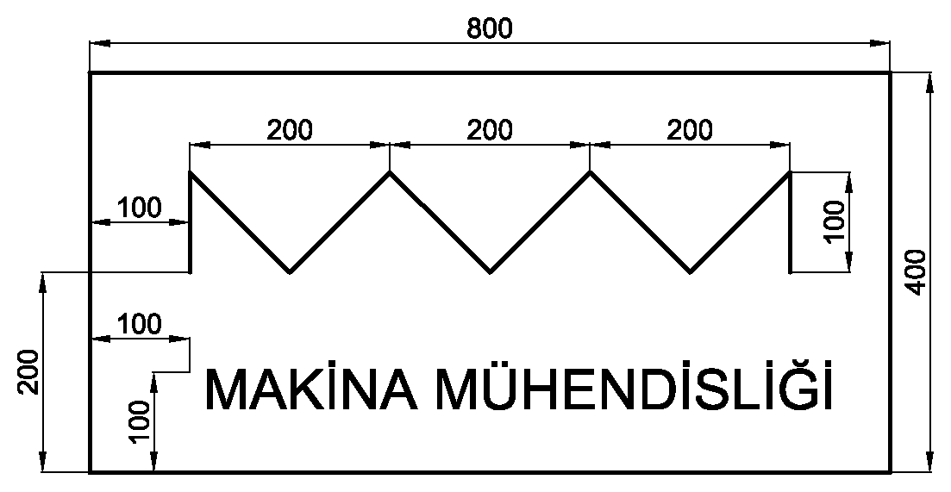

Dim RESİM As New Bitmap(PictureBox1.Width, PictureBox1.Height)
Dim ÇİZ As Graphics = Graphics.FromImage(RESİM)

ÇİZ.DrawLine(New Pen(Color.Black, 3), 100, 200, 100, 100)
ÇİZ.DrawLine(New Pen(Color.Black, 3), 100, 100, 200, 200)
ÇİZ.DrawLine(New Pen(Color.Black, 3), 200, 200, 300, 100)
ÇİZ.DrawLine(New Pen(Color.Black, 3), 300, 100, 400, 200)
ÇİZ.DrawLine(New Pen(Color.Black, 3), 400, 200, 500, 100)
ÇİZ.DrawLine(New Pen(Color.Black, 3), 500, 100, 600, 200)
ÇİZ.DrawLine(New Pen(Color.Black, 3), 600, 200, 700, 100)
ÇİZ.DrawLine(New Pen(Color.Black, 3), 700, 100, 700, 200)

ÇİZ.DrawString("MAKİNA MÜHENDİSLİĞİ", New Font("ARIAL", 16), Brushes.Black, 100, 300)

PictureBox1.Image = RESİM

Tabloya ekleme
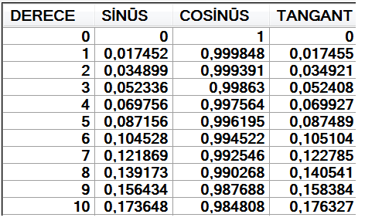

For R = 0 To 360
Dim RADYAN = R * Math.PI / 180

DataGridView1.Rows.Add(R, _
Math.Round(Math.Sin(RADYAN), 6), _
Math.Round(Math.Cos(RADYAN), 6), _
Math.Round(Math.Tan(RADYAN), 6) _
)

If R = 90 Or R = 270 Then _
DataGridView1(3, DataGridView1.Rows.Count - 1).Value = "TANIMSIZ"

Next R

DataGridView1.AutoResizeRows()
DataGridView1.AutoResizeColumns()

TABLODAN DOSYAYA YAZMA
Private Sub DATAGRIDVIEW1_KAYDET
SaveFileDialog1.InitialDirectory = Application.StartupPath
SaveFileDialog1.Filter = "TXT|*.TXT|*.*|*.*"
SaveFileDialog1.FileName = "PROGRAM.TXT"
If SaveFileDialog1.ShowDialog() <> Windows.Forms.DialogResult.OK Then Exit Sub

FileOpen(1, SaveFileDialog1.FileName, OpenMode.Output, OpenAccess.Write)
For R = 0 To DataGridView1.Rows.Count - 1
Print(1, DataGridView1(0, R).Value)
For C = 1 To DataGridView1.Columns.Count - 1
Print(1, Chr(9) & DataGridView1(C, R).Value)
Next
PrintLine(1, "")
Next

FileClose()
DataGridView1.AutoResizeColumns()
DataGridView1.AutoResizeRows()
End Sub

DOSYADAN TABLOYA OKUMA
SUB DATAGRIDVIEW1_OPEN
OpenFileDialog1.InitialDirectory = Application.StartupPath
OpenFileDialog1.Filter = "TXT|*.TXT|*.*|*.*"
OpenFileDialog1.FileName = "PROGRAM.TXT"
If OpenFileDialog1.ShowDialog() <> Windows.Forms.DialogResult.OK Then Exit Sub
DataGridView1.Rows.Clear()

FileOpen(1, OpenFileDialog1.FileName, OpenMode.Input)
Do While Not EOF(1)
DataGridView1.Rows.Add(Split(LineInput(1), Chr(9)))
DataGridView1.RowHeadersVisible = True
Loop
FileClose()
DataGridView1.AutoResizeColumns()
DataGridView1.AutoResizeRows()
END SUB

YAZDIRMA

YAZDIRMA KODLARI

SUB DATAGRIDVIEW1_YAZDIR_DOCUMENT1
REM PRINTDOCUMENT1 NESNESİNE YAZILIR
Dim C = ({12, 34, 72, 107, 137, 197})
Dim yx = 5
e.Graphics.PageUnit = GraphicsUnit.Millimeter
e.Graphics.DrawImage(PictureBox1.Image, C(0), 125 + yx, 140, 140)

For r = 0 To DataGridView1.Rows.Count - 1
e.Graphics.DrawString(DataGridView1(0, r).Value, _
New Font("ARIAL", 12, FontStyle.Bold), _
Brushes.Black, C(0), r * 8 + 30 + yx)

e.Graphics.DrawString(DataGridView1(1, r).Value, _
New Font("ARIAL", 12, FontStyle.Bold), _
Brushes.Black, C(1), r * 8 + 30 + yx)

e.Graphics.DrawString(DataGridView1(2, r).Value, _
New Font("ARIAL", 12, FontStyle.Bold), _
Brushes.Black, C(2), r * 8 + 30 + yx)

e.Graphics.DrawString(DataGridView1(3, r).Value, _
New Font("ARIAL", 12, FontStyle.Bold), _
Brushes.Black, C(3), r * 8 + 30 + yx)

e.Graphics.DrawString(DataGridView1(4, r).Value, _
New Font("ARIAL", 12, FontStyle.Bold), _
Brushes.Black, C(4), r * 8 + 30 + yx)
Next
REM YATAY ÇİZGİLER
e.Graphics.DrawLine(New Pen(Brushes.Black, 0.5), C(0), 30 + yx, C(5), 30 + yx)
e.Graphics.DrawLine(New Pen(Brushes.Black, 0.5), C(0), 38 + yx, C(5), 38 + yx)
e.Graphics.DrawLine(New Pen(Brushes.Black, 0.5), C(0), 46 + yx, C(5), 46 + yx)
e.Graphics.DrawLine(New Pen(Brushes.Black, 0.5), C(0), 54 + yx, C(5), 54 + yx)
e.Graphics.DrawLine(New Pen(Brushes.Black, 0.5), C(0), 62 + yx, C(5), 62 + yx)
e.Graphics.DrawLine(New Pen(Brushes.Black, 0.5), C(0), 70 + yx, C(5), 70 + yx)
e.Graphics.DrawLine(New Pen(Brushes.Black, 0.5), C(0), 78 + yx, C(5), 78 + yx)
e.Graphics.DrawLine(New Pen(Brushes.Black, 0.5), C(0), 86 + yx, C(5), 86 + yx)
e.Graphics.DrawLine(New Pen(Brushes.Black, 0.5), C(0), 94 + yx, C(5), 94 + yx)
e.Graphics.DrawLine(New Pen(Brushes.Black, 0.5), C(0), 110 + yx, C(5), 110 + yx)
e.Graphics.DrawLine(New Pen(Brushes.Black, 0.5), C(0), 118 + yx, C(5), 118 + yx)
REM DÜŞEY ÇİZGİLER
e.Graphics.DrawLine(New Pen(Brushes.Black, 0.5), C(0), 30 + yx, C(0), 94 + yx)
e.Graphics.DrawLine(New Pen(Brushes.Black, 0.5), C(1), 30 + yx, C(1), 94 + yx)
e.Graphics.DrawLine(New Pen(Brushes.Black, 0.5), C(2), 30 + yx, C(2), 94 + yx)
e.Graphics.DrawLine(New Pen(Brushes.Black, 0.5), C(3), 30 + yx, C(3), 94 + yx)
e.Graphics.DrawLine(New Pen(Brushes.Black, 0.5), C(4), 30 + yx, C(4), 94 + yx)
e.Graphics.DrawLine(New Pen(Brushes.Black, 0.5), C(5), 30 + yx, C(5), 94 + yx)
END SUB

YAZDIRMANIN BAŞLATILMASI

SUB DATAGRIDVIEW1_YAZDIR_BUTTON1_CLICK
If PrintDialog1.ShowDialog() <> Windows.Forms.DialogResult.OK Then Exit Sub
PrintDocument1.DefaultPageSettings.Landscape = False
PrintDocument1.DefaultPageSettings.PrinterSettings.PrinterName = _
PrintDialog1.PrinterSettings.PrinterName
PrintDocument1.Print()
END SUB

